**Minesweeper**

**Team Members:**

* Kartik Malik (20124026)
* Pranav Dev (20124037)
* Raj Jaiswal Aman (20124038)

**About the Game:**

The game is played by revealing squares of the grid by clicking or otherwise indicating each square. If a square containing a mine is revealed, the player loses the game. If no mine is revealed, a digit is instead displayed in the square, indicating how many adjacent squares contain mines; if no mines are adjacent, the square becomes blank, and all adjacent squares will be recursively revealed. The player uses this information to deduce the contents of other squares and may either safely reveal each square or flag the square as potentially containing a mine.

**Idea of project:**

We have built a Minesweeper game which is a single-player puzzle video game. The objective of the game is to clear a rectangular board containing hidden "mines" or bombs without detonating any of them, with help from clues about the number of neighboring mines in each field.

**Running the project:**

The project was built upon Android Studio and we used third-party dependencies for some features which you can find in the activity_main.xml file. To run the project on your pc you can import the project in Android Studio and run it by running MainActivity.java. Generated apk can also be installed and run on android phones.

**Structure of the project:**

For every feature, we have built a separate class in a separate file and some static methods in it so that we can access them without creating an instance of that class.

We used XML to create the layout of the game. The icons which we have used can be found in the Drawable folder of the source directory as .pngs.

**Errors in running the project:**

*We have tested several times and we got no error while testing every feature of the app several times.*

Still, if you are getting an error while running the app you can try updating your Android Studio.

**Screenshots of the final application:**

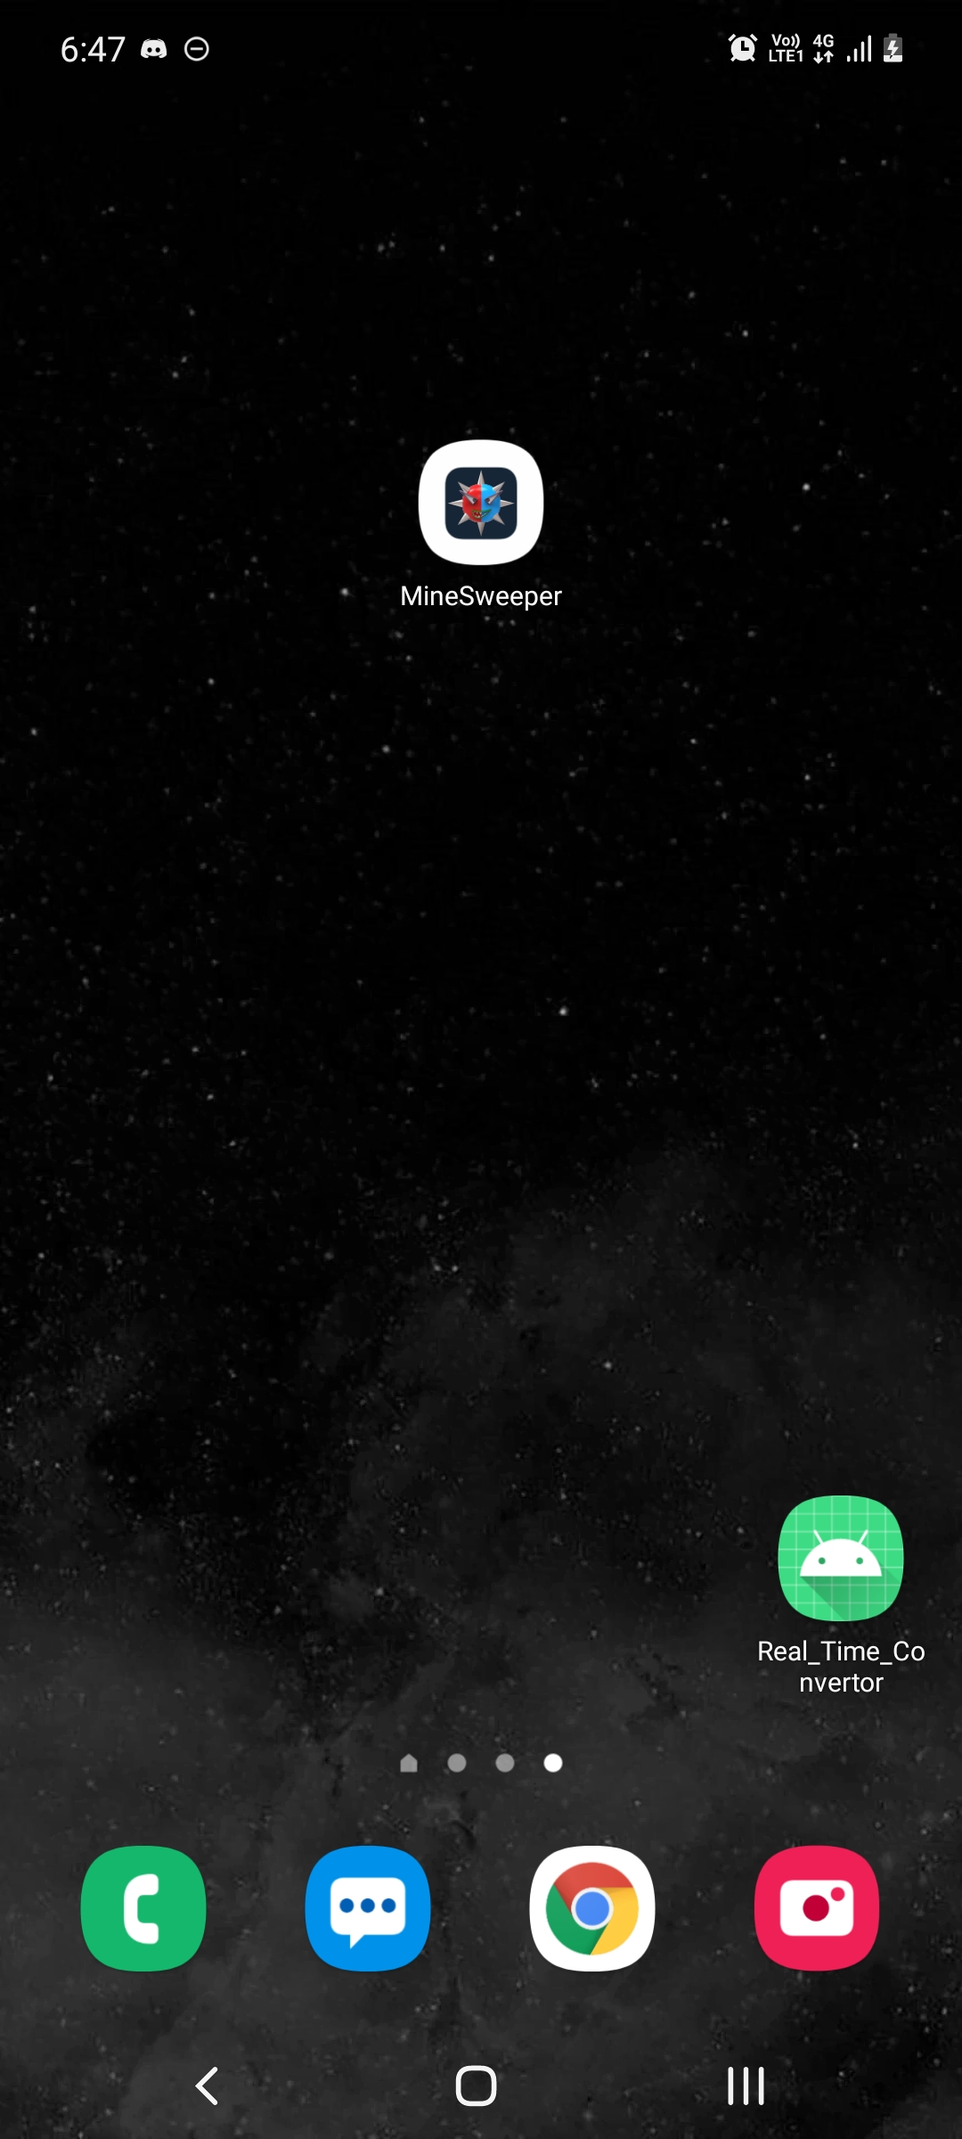

Application and its Icon.

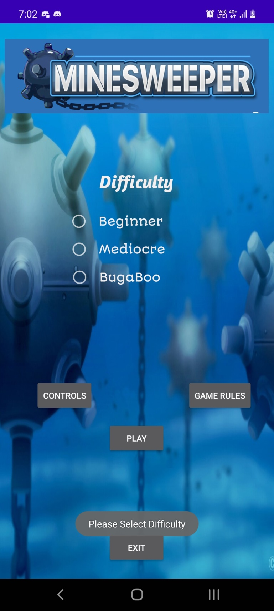

Main menu and asking to select difficulty if not selected initially.

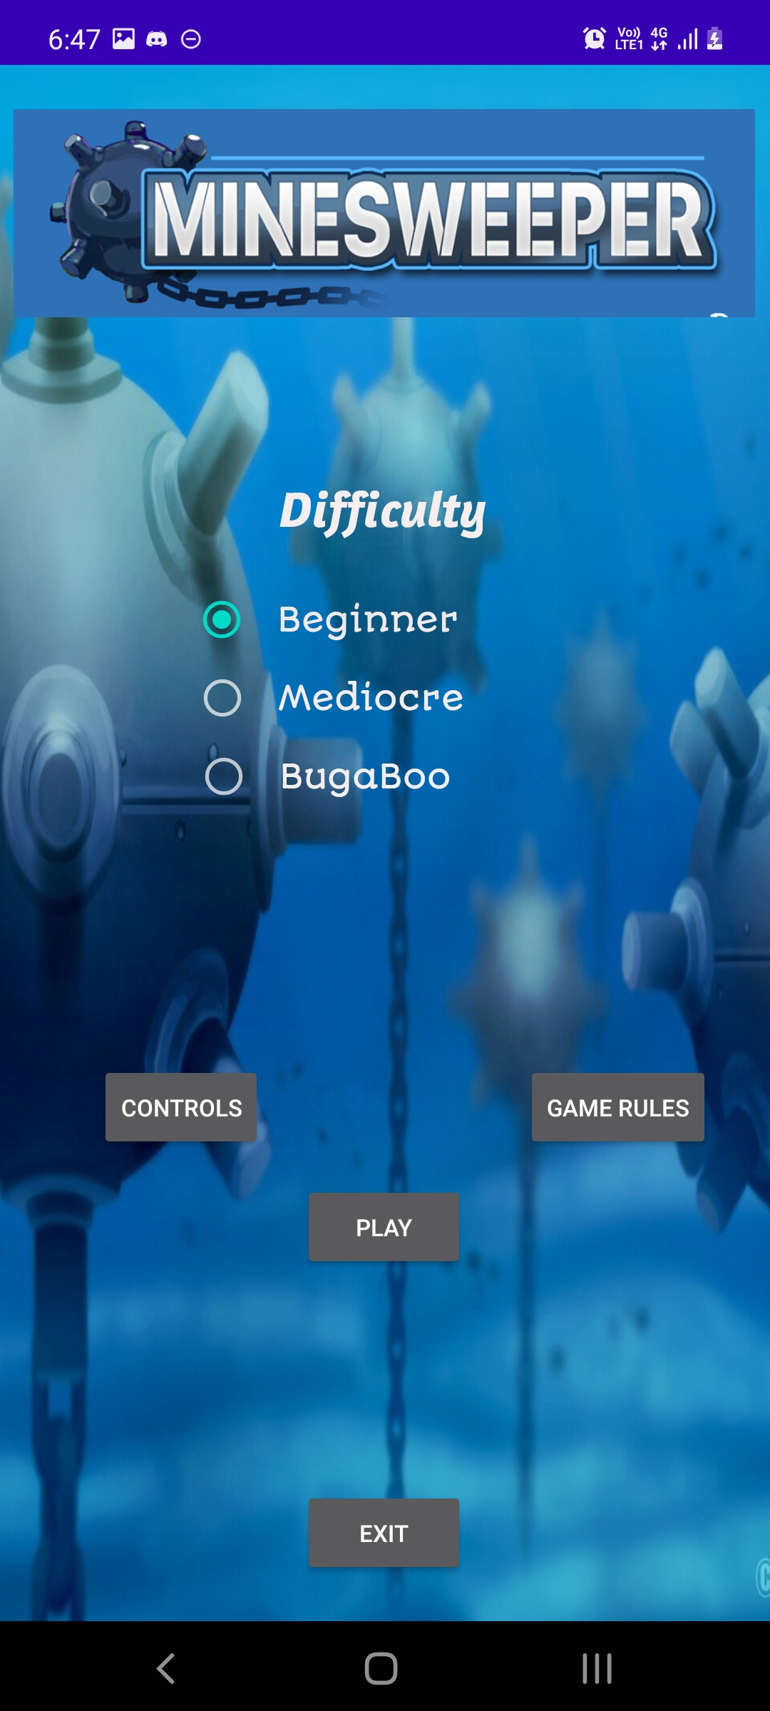

Main Menu

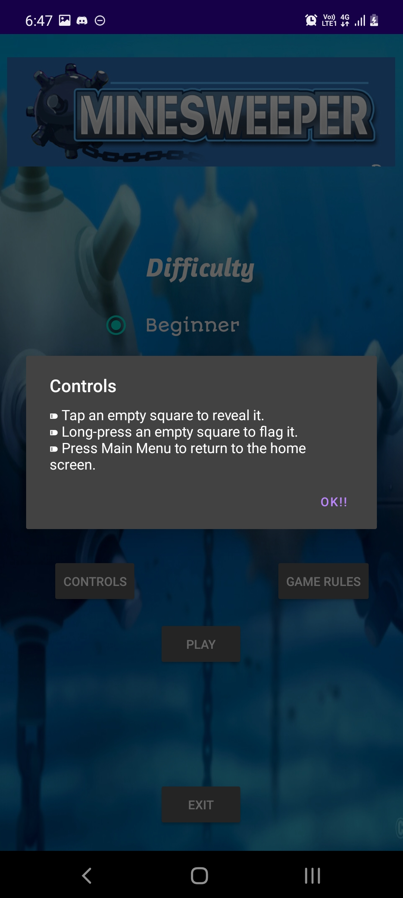

Controls Dialog Box being displayed.

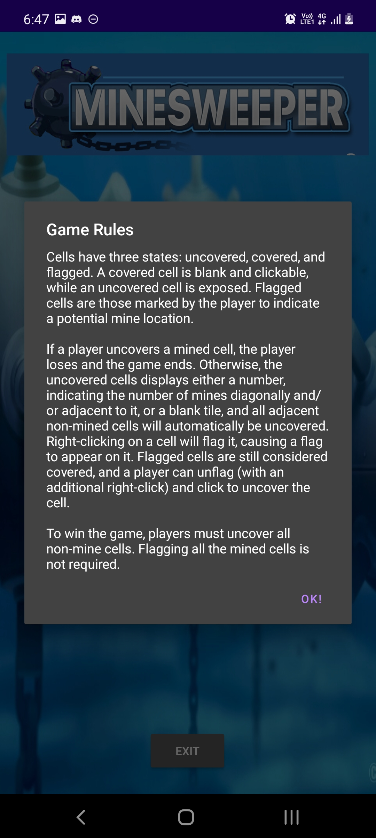

Game Rules Dialog Box being displayed showing rules how to play game.

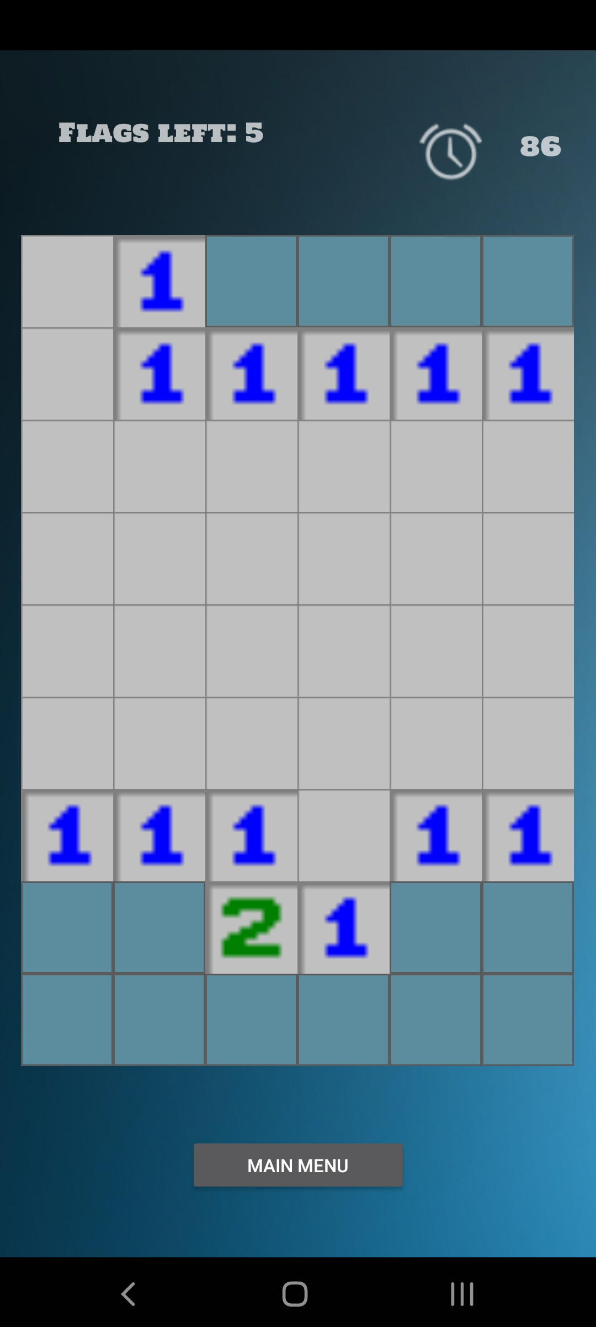

Clicking on play button and Playing the game in beginner difficulty level.

Displaying the no of remaining flags and count down timer.

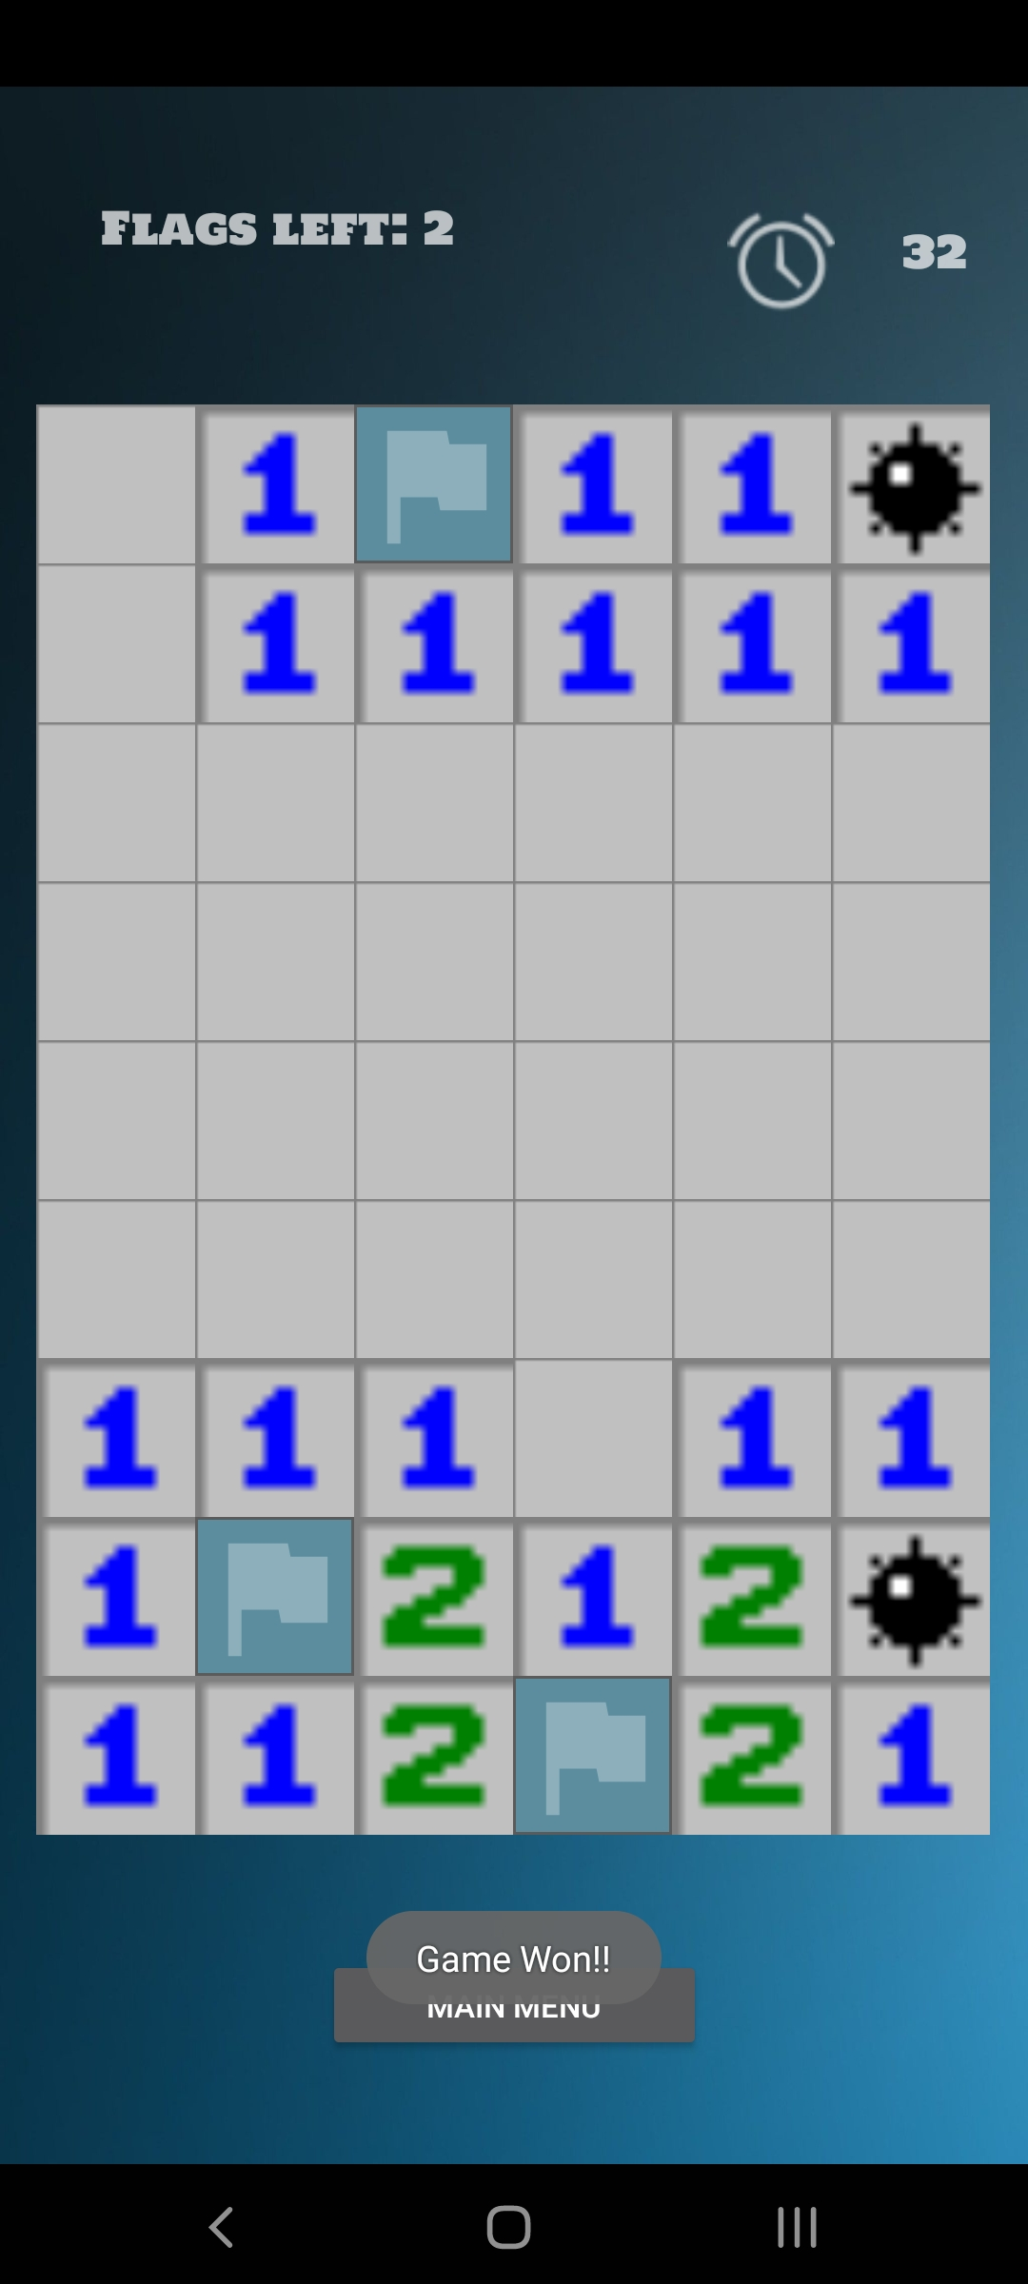

Playing the game and getting proper response/result.

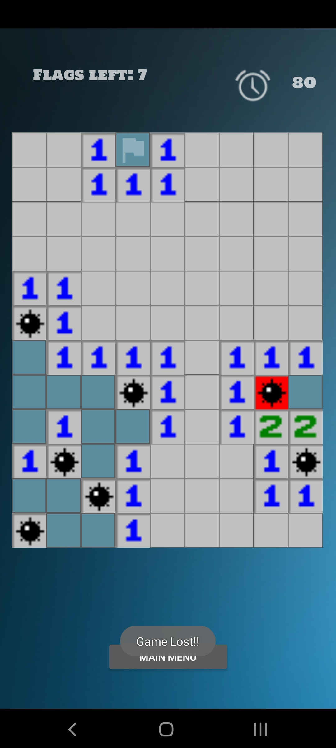

Playing mediocre level and getting appropriate response.

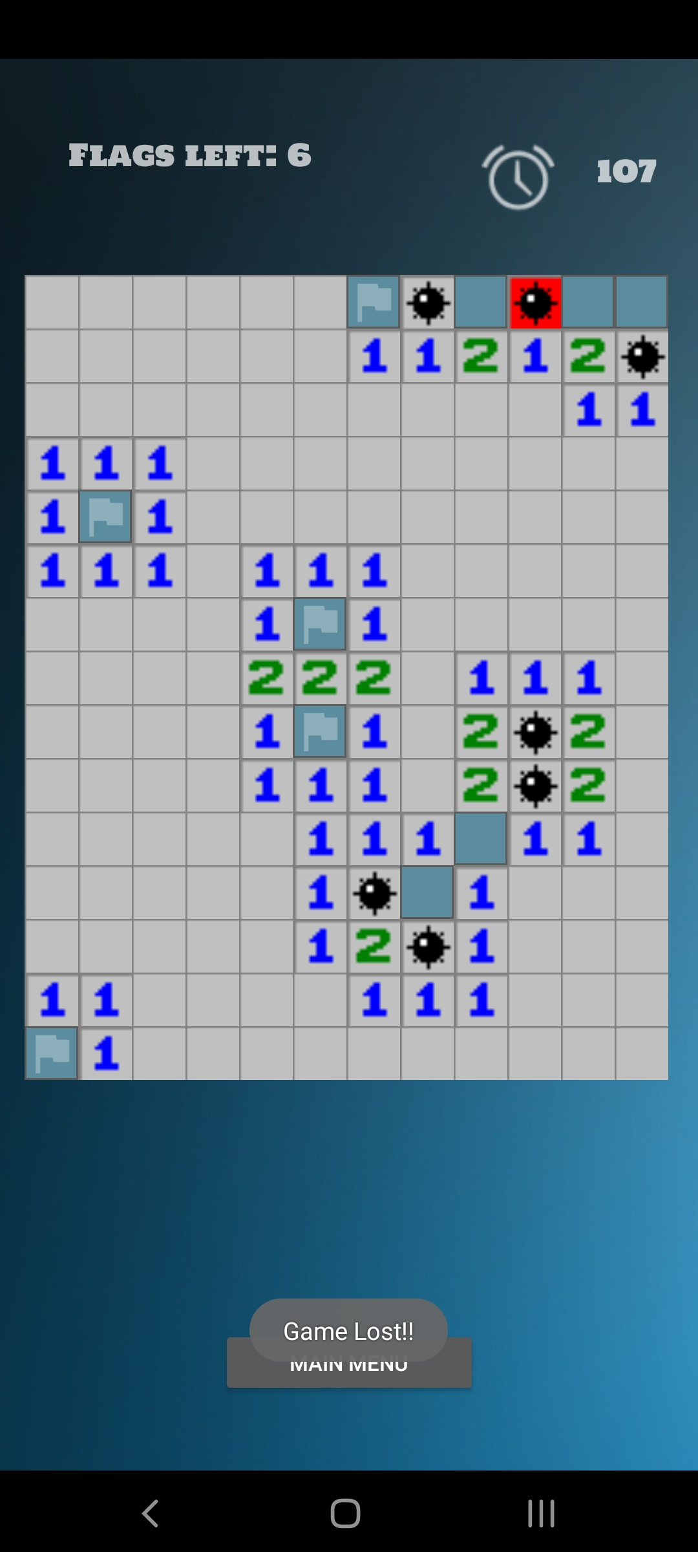

Playing BugaBoo level and getting appropriate response

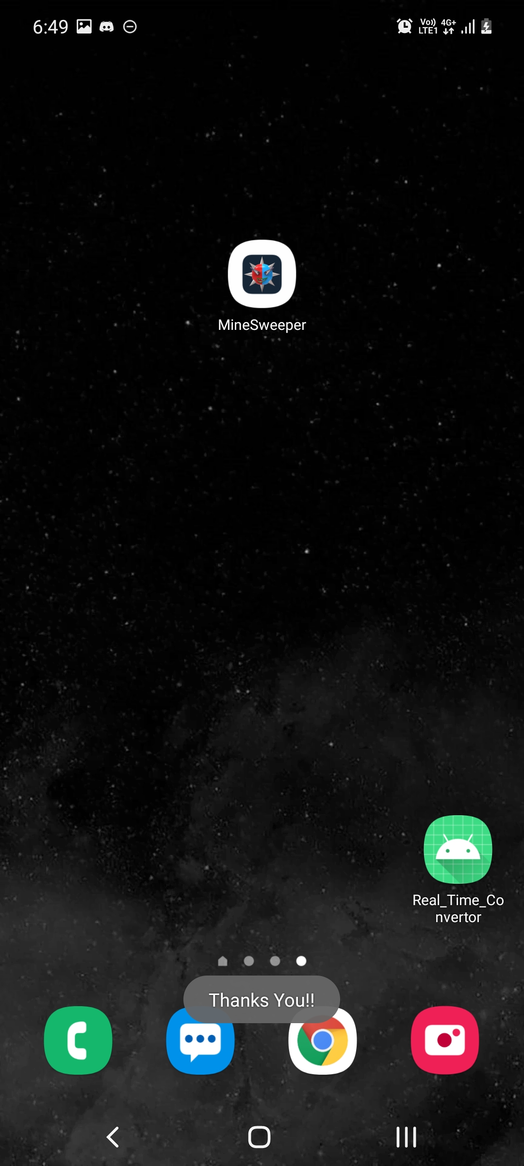

Just informal greeting after clicking on Exit button.